Administration Manual

PaDS

James Woosnam & Julian Gates
6.0b - PEPWeb Integration – 18^{h} Aug 2021

Zedra Solutions Ltd
The Warren
Itchen Abbas,
Winchester,
Hampshire SO21 1AX

Tel: 01962 738884
WWW: zedra.co.uk

contact@zedra.co.uk
Table of contents
1. Introduction 4
2. General Setup 4
2.1 PaDS System Usernames and Passwords (LastPass) 4
2.2 Pads Source Code 4
2.3 Pads Additional Software 4
3. Server Setup 4
3.1 Amazon EC2 Cloud Setup 4
3.2 Windows Setup 8
3.3 SQL Server Setup 12
4. Application Setup 12
4.1 Pads Batch Control Setup 12
4.2 Email Setup 13
4.3 Databases 13
4.4 Database Backup to Secondary Server 14
4.5 Admin Client Software 14
4.6 Website 14
4.7 Drop Box 17
4.8 Web Reporting 18
4.9 CyberSource 19
4.10 PEP Secure Application Setup 21
4.11 Federated Application Setup 24
5. Application Security 26
5.1 General 26
5.2 Security Groups 27
5.3 Access Rights 27
5.4 Technical Implementation 28
6. SERVER CHECKS and Alerts 29
6.1 PaDs Checks 29
7. “Read Only” and “Failover” Modes 29
7.1 “Read Only” Mode 29
7.2 “Failover” Mode 29
7.3 Recover from “Failover” Mode 30
8. Backup 31
9. PaDS Maintenance and Procedures 31
9.1 PaDS Release to Test 31
9.2 PaDS Release to Live 32
9.3 Merging PaDS changes to Github version in Visual Studio 33
9.4 Take Snapshot and Install Windows Updates 34
9.5 Microsoft Monthly Updates 35
9.6 AWS Volumes Disk Sizing 36
9.7 Clover Security PCI compliance 36
9.8 Clover Security PCI compliance vulnerabilities fix 2020 37
9.9 Amazon Test Server Setup 37
9.10 Enable PepWeb Universal Content 39
10. Open Source and GitHub 39
11. PEPweb Authorisations and Content Sets 40
11.1 Content Catalogue Synchronisation 40
11.2 Content Sets 40
11.3 Sales Orders, Products & Subscriptions 42
11.4 Admin Access 42
11.5 Universal Access 42
12. Appendix A – document Control 43
12.1 Document History 43

Introduction
This document sets out the information about the tasks that can be undertaken to administer PaDS. It is a working document in that it will evolve as new admin techniques become known.

General Setup

PaDS System Usernames and Passwords (LastPass)
All user names and passwords for Pads can be found in LastPass online password manager.
LastPass ( https://lastpass.com/) is a leading online password management system which is used to store all our critical security and password information. Within LastPass it is possible to share selected information with other LastPass users, therefore it would be possible to allow some trusted PEP and/or IJP people access to this.

Pads Source Code
A full version of the latest Pads Source code is stored in a zip file on Dropbox. Directory: \Dropbox\PaDSLive\PaDSSourceCode\
From 2021 the source code will also be stored in GitHub, see section 10 Open Source and GitHub

Pads Additional Software
Any additional software needed for Pads server configuration can be found at Pads01 C:\PaDS\Software.

Server Setup

Amazon EC2 Cloud Setup
There are two servers are running in Amazon’s EC2 cloud server which can be accessed at:
https://console.aws.amazon.com
Logon details can be found in LastPass under Amazon - Pads.
We are using 2 servers in the US East region. They are based on the “Microsoft Windows Server 2016 Datacenter edition” instance which includes the following:
Microsoft Windows Server 2016 Datacenter edition, 64-bit architecture, Microsoft SQLServer 2017 Express, Internet Information Services 8, ASP.NET 4.7.1
Type: m5.large
Key Pair Name: ZedraKey1.pem - this is required to get the servers administrative password if it is lost or if a new server is created. It is stored in Z:\Correspondence\Amazon and in LastPass

Amazon Firewall
The Amazon firewall has been setup with the following configuration:
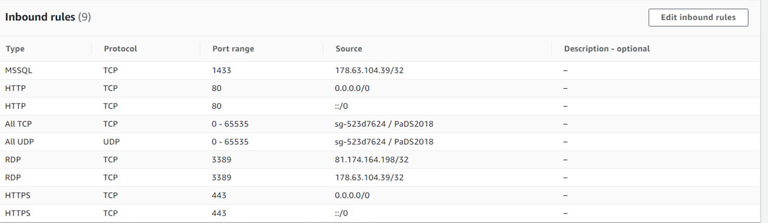
178.63.104.39/32 – this is Zedra’s fixed IP and allows them to connect directly from the main development server.
81.174.164.198/32 – this is Zedra’s Plusnet broadband fixed IP and allows James Woosnam to connect directly from his office.
The database connections and replication can only use the internal IP addresses via the server names PaDS01/02 if the hosts file on both servers have been set up (see section 3.2.b).
The “All” lines are vitally important as this allows all servers in the security group to see all other servers.

Elastic IPs
Amazon provides these to ensure that the servers have the same public IP addresses if they are stopped and restarted. They are free as long as they are attached to a running server.

Primary Server
Amazon EC2 M5.Large
IIS 8 and SQL Server 2017 Express
Server Name: PaDS01 New Live
SQL Server Name: Pads01
Elastic IP: 34.202.154.34

Secondary Server
Amazon EC2 M5.Large
IIS 8 and SQL Server 2017 Express
Server Name: PaDS02
SQL Server Name: Pads02
Elastic IP: 52.200.214.35

Amazon Load Balancer
This spreads traffic between both servers and, if one server fails, will route traffic to surviving server.
The Load Balancer ELB needs to have:
- 2 Target Groups - one HTTP and 1 HTTPS. Must have sticky sessions enabled, see below
- 2 listeners, HTTP & HTTPS, pointing at 1 target group each. The listener needs the www.psychoanalystdatabase.com issued by Amazon (see section 3.2.h)
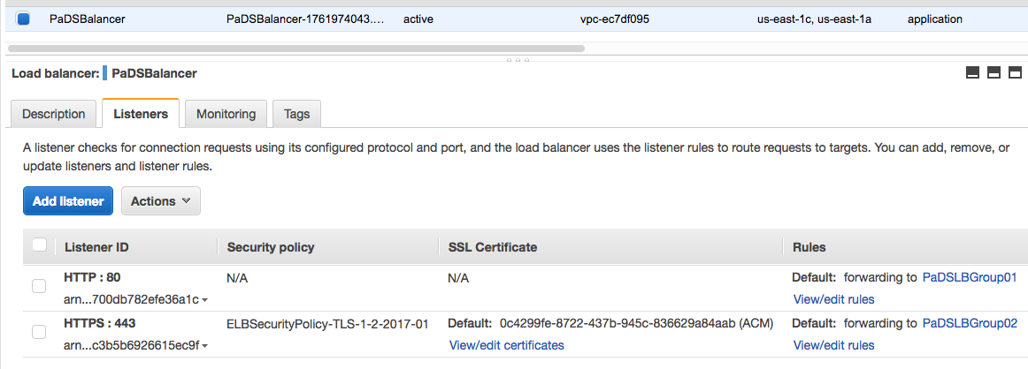
Security Policy
The security policy of the load balancer needs to be set to TLS 1.2
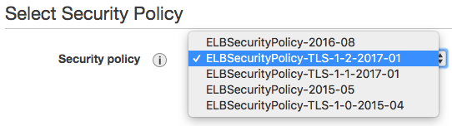
Sticky Sessions
To enable sticky sessions using the console
- Open the Amazon EC2 console at https://console.aws.amazon.com/ec2/.
- On the navigation pane, under LOAD BALANCING, choose Target Groups.
- Select the target group.
- On the Description tab, choose Edit attributes.
- On the Edit attributes page, do the following:
  - Select Enable load balancer generated cookie stickiness.
  - For Stickiness duration, specify a value between 1 second and 7 days.
  - Choose Save.
- 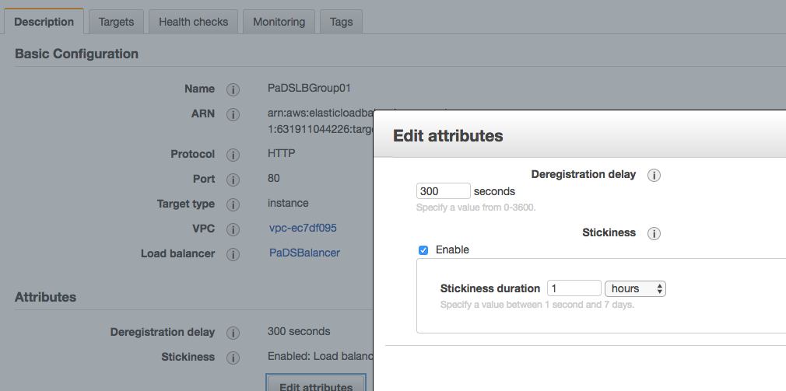

Route53 Health Checks
Amazon Route 53 health checks enable you to monitor the health of your resources such as web servers and email servers and notify Zedra if there are issues. The health checks need to be set up as screen shots below and point to the relevant Elastic IP addresses.

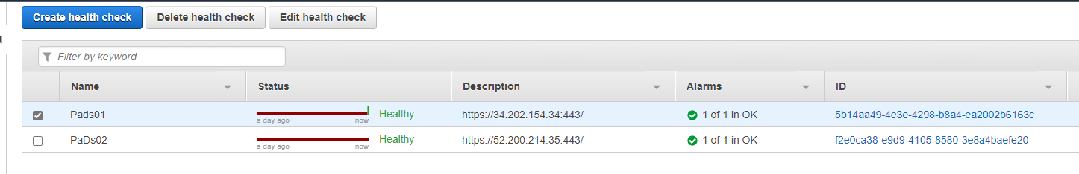

PaDS01
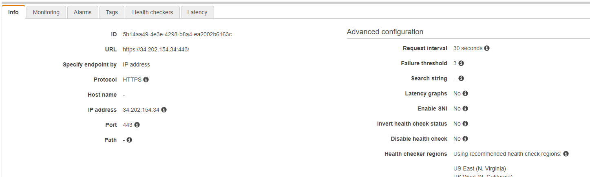

PaDS02
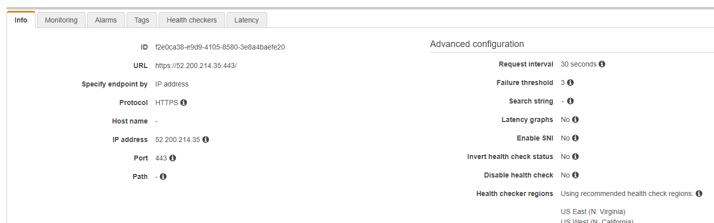

AWS Volumes Disk Sizing
See section 9.5.

Reserved Instances
Amazon allows you to buy “Reserved Instances”. This is effectively committing to the servers for a fixed term, 3 years, at a reduced cost per hour. There are currently Reserved Instances until March 2021.
26/3/21: Three new 3 year reserved instances purchased. The 3rd one if for the test server which is now always on line.

Windows Setup

Windows Firewall
The Windows Firewall should be disabled on both servers.

Hosts File
The servers are called PaDS01 & PaDS02 and can be used as such in SQL and replication, but these names are only available if the Windows hosts file in: C:\Windows\System32\drivers\etc has a line pointing the name to the Internal IP Address. The Internal IP Address changes every time the server is stopped and started so the hosts file needs to be updated:
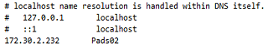

Windows Server 2016 Datacenter Setup
In Windows Server Manager make sure the IIS setup configuration is per the image below.

Make sure that the server locale has been set to English (United Kingdom) by navigating to Control Panel\Clock, Language, and Region and select Set System Locale button as per screenshot below.

TLS Setup
May 2017 TLS v1.2 was enabled in Pads01 and Pads02 server’s registry, as Cybersource were disabling TLS v1.0 and TLS v1.1 as deemed now un-secure.

After disabling TLS1.0 you need to update the following registry entry to get .NET Framework to use the new TLS1.2 protocol to connect to Cybersource.

[HKEY_LOCAL_MACHINE\SOFTWARE\Microsoft\.NETFramework\v4.0.30319]
"SchUseStrongCrypto"=dword:00000001

[HKEY_LOCAL_MACHINE\SOFTWARE\Wow6432Node\Microsoft\.NETFramework\v4.0.30319]
"SchUseStrongCrypto"=dword:00000001

Also see section Error! Reference source not found.

Activating a Cloned Windows Instance
Windows Activations can fail when an instance cannot reach the AWS KMS servers. This can be due to an incorrect Windows route table. Prior to Windows 2016, the EC2Config service used to take care of setting the Windows route table. Now 2016 EC2Launch takes on some of these tasks. In this case, the failing instance likely has incorrect route entries from the cloned instance subnet.

Resolving the issue:
1. Do a telnet test to the KMS servers from the instance: (view 3.2f section for enabling Telnet)
telnet 169.254.169.250 1688
telnet 169.254.169.251 1688

2. Confirm required routes to KMS servers route print example output:
169.254.169.250 255.255.255.255 <Subnet default Gateway> <ENI IP Address> 10
169.254.169.251 255.255.255.255 <Subnet default Gateway> <ENI IP Address> 10

If the entries don't match your subnet, delete existing routes:
route DELETE 169.254.169.251
route DELETE 169.254.169.250

If no matching entries exist, please add them by using the following in a CMD prompt:
route -p ADD 169.254.169.251 MASK 255.255.255.255 <Subnet default Gateway> route -p ADD 169.254.169.250 MASK 255.255.255.255 <Subnet default Gateway>

3. Re-test telnet connection:
telnet 169.254.169.250 1688
telnet 169.254.169.251 1688

If the telnet tests fail again, confirm that there is no firewall or security software installed on the instance that is blocking the traffic. Also check on security groups and network ACLs on the instance that this traffic is not blocked. Once networking communication has been resolved, please run the following command from a CMD prompt to reactivate Windows:
slmgr /ato

Enabling the Telnet Client through Command Prompt
If you need to install Telnet to fix windows activation then using the command line is the easiest and fastest way to install the telnet client. Run the command below in command prompt with administrator permissions.
dism /online /Enable-Feature /FeatureName:TelnetClient
That’s it. After a few seconds telnet should be ready to use.

Windows Activation Check every 180 Days fails.
If windows activation fails, you can run the following command line command manually.
slmgr /ato

SSL Certificate
As of March 2018, we are using an Amazon certificate on the Amazon load balance. This certificate comes free with the Amazon server and is used instead of the certificate on the server.
Aug 2021: Certificates for pads.pep-web.org & stage-pads.pep-web.org have been created and attached to the relevant load balancers.
29/3/18 James: I did a test by removing the test1.zedra.net GoDaddy certificate from the Windows server and all seemed fine. I also tried the balancer.psychoanalystdatabase.com domain and that was fine.
Conclusion: We will not need to renew the DigitCert certificate.

SQL Server Setup
Configuration > Protocols for SQL Server” has the protocols TCP/IP and Named Pipes set to “Enabled”.
Make sure that SQL Server and Windows Authentication mode are enabled.
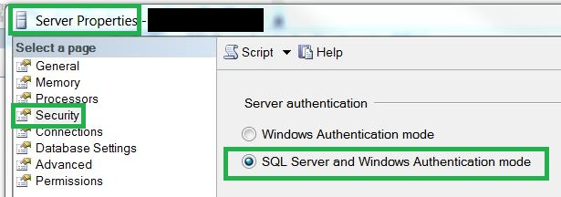
MS SQL Server Management Studio is already part of the AWS machine.
Management Studio software, should be available in programs menu

Application Setup

Pads Batch Control Setup
The PaDS batch controller is a Windows service which is used to run regular batch jobs or jobs which are submitted from the front end and can then run in the background.
For a 64-bit server, you need to setup the Pads Batch control registry entries in the Wow6432Node section as shown below:
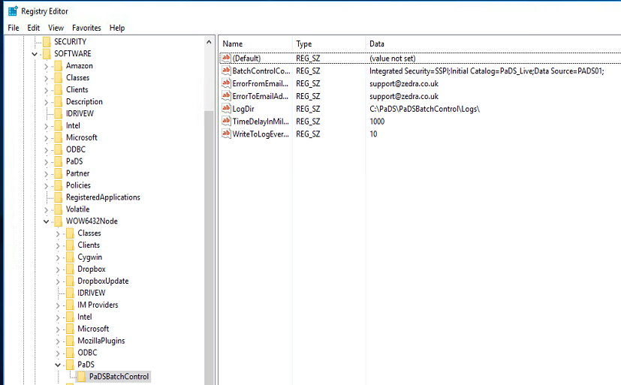
When Installing Pads Batch Control, you need to put a dot in front of the username that will be running the service, eg .\ZedraAdmin

Batch Control Config File
The batch control needs a configure file in the batch control directory. This points to the correct CyberSource.

Log Files
Ensure a folder exists (with correct permissions) called Logs. This folder should be in the same folder as the PadsBatchControl.

Email Setup
All emails sent from Pads use vb.net and send emails via a google apps account set up for psychoanalystdatabase.com.
http://mail.google.com/a/psychoanalystdatabase.com

All mail is routed through “sales” user. The password for this account can be found in LastPass under “Pads Email Setup”.

Databases
The databases are constructed in Microsoft SQL Server 2017 Express and are installed on the primary server. The SQL Server database files and transaction log for PaDS are stored in C:\Data\MSSQLThe latest database code can be found in C:\PaDS\SQLLive\.
There are two databases:
- PaDS_Live – used for live data
- PaDS_Logs – Used to store logging information.

To compile all Pads SQL files on the database, you need to run PadsTestHarness on Pads01 and select Compile1 button.
C:\Pads\PaDSTestHarness\ PaDSTestHarness.exe

Database Backup to Secondary Server
As of March 2018, PaDS no longer uses inbuilt SQL Server replication. There is now an application process running as a scheduled job under the PaDS Batch Control service. This job backs up both PaDS databases on the primary server and copies, and sets them up, on the secondary server. This process runs every ½ hour.

Admin Client Software
Jan 2021: No longer used.

Website
The main PaDS system runs under ASP .NET and ISS on the PaDS01 server. This is the only website supported by the server.
All the website code is stored in C:\wwwroot\PaDS_Live. TheASP.NETdirectories are as follows:
Directory Location | Comment
..\common\ | Stores various ASP code that is linked into the ASP and ASP .NET pages as required.  ApplicationParameters.asp - This is a key file for ASP as it stores all the global variable used in the system including ADO connection strings and ODBC connections for classic ASP pages.
..\images\ | Any images used on the site
..\masterObjects | Master pages used in ASP .NET
..\pages\ | Each file in this directory produces an ASP or ASP .NET page.
..\Reports\ | This directory is used for the temporary storage of any reports generated on the system. The reports are then downloaded to the user’s PC.  On the live server this is stored in c:\PaDSFiles\Reports which is shared. IIS has a virtual IIS directory which points at this share using zedraadmin as the “Connect As”
..\ReportTemplates\ | These are word and excel templates used for generating reports within the system. They can be accessed for user maintenance via Dropbox.  If you get a message saying that Report failed : Microsoft Excel cannot access the file. You will need to add an empty directory called Desktop in the following location on the server.  (32Bit, always)  C:\Windows\System32\config\systemprofile\Desktop  (64Bit)  C:\Windows\SysWOW64\config\systemprofile\Desktop

PEPProduct Application Pool Setup in IIS8
PEPProduct needs to run under its own Application pool in IIS. To set this up, use the following procedure.
- In IIS8 add a new application pool called ForPEPProduct and leave the default settings.
- Next, right-mouse click on the new application pool and from the dropdown menu select “Advanced Settings”. The following settings box will be shown as below:
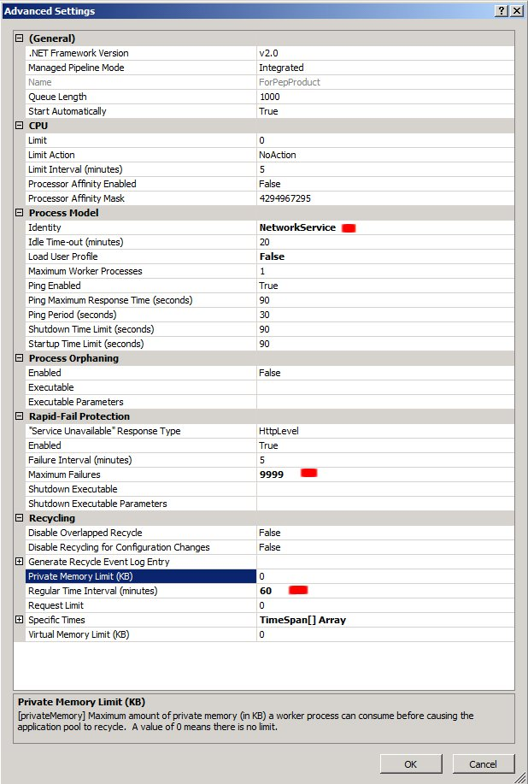
Items marked with a red box need to be set to the settings shown in the above image.
- In IIS8, double click the PEPProductLive application within Pads_Live folder and then select Basic Settings link within the right-hand side “Actions” panel.
- Within the Edit Application pop-up, change the application pool to the new ForPEPProduct pool and press ok.

Web Config file
To allow correct encoding of the view state, the machine key needs to be the same on both servers. This is added to the system.web section of both servers.
<machineKey validationKey="2A0CB0F25E4DFCC0B08724B69D988808ED7E0B3D2C747853600280F21
DBF8F79E37E881A752177F06CA8DA6E660F60D69A96D14A4CB343E4392F77D311276CBF"
decryptionKey="7EF79A0279D1EA96A44523FBF994718CD0C15A796FE5778CE66D230915B11970"
validation="SHA1"
decryption="AES"
/>
See for more info: https://blogs.msdn.microsoft.com/amb/2012/07/31/easiest-way-to-generate-machinekey/
Make sure connection strings are updated correctly in Web.config and in Common\ApplicationParameters.asp page.
After adding new PADS02 server we need to add the following to the Web.config on Pads01 and Pads02 to stop the Invalid postback or callback argument error.
<system.web>
<pages enableEventValidation="false"/>
</system.web>

DevExpress
PaDs is currently using DevExpress v19.2.5.0

Drop Box
All updatable files used in PaDS are handled in Dropbox at the following location C:\Dropbox\PaDSLive on each PaDS server.
PEP & IJP
PaDS Source Code
Terms and Conditions
Report Templates (Invoices/Receipts)
XLS Import Template No longer used
XLS Subscriber Import Source. No longer used
XLS Subscriber Import Loaded. No longer used
Transfer (Secure file transfer area)
Files within these folders are automatically available in the PaDS front end via the file share \\PaDs01\Dropbox\. If Dropbox location is changed, then the following parameters in the PaDS01 stblParameters database table must be updated:
- ReportTemplateDirectory
- TermsConditionsDirectoryPhysicalPath
Dropbox website: https://www.dropbox.com/home#/. This allows the files to be maintained via a user-friendly website.
UserId: contact@zedra.co.uk
PW: Can be found in LastPass
If you are not already using Dropbox then you can install it on your own PC which will allow you to drag files in and out of the directory it creates on your PC and these will then be synchronised with the PaDS server.
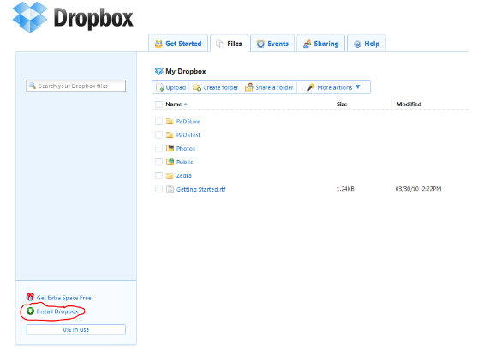
June 2021: As a free DropBox account can only have 3 logins the live setup has been changed so that only server PaDS01 has the DropBox client. Both servers Pads01 & PaDs02 now reference the file share \\PaDS01\Dropbox.
June 2021: A Dropbox sync check has been added to the PaDS checks.

Web Reporting
Reports on the web are produced using the PadsBatchControl Windows service (see section 4.1.).
All reports are submitted from the web front end where all information required to run the reports is added to a new batch job record as parameters. The batch control Windows service then uses these parameters to build the reports and provide a link to the report from the front end.
There are several different types of report:
- Excel Macro Pivot Table Reports (GenericPivot)– The batch job parameters contain the query SQL which is then used to build data tables which are injected into Excel. .NET Excel automation is then used to run a macro in the Excel template which formats the pivot table.
- Excel Listing Report (GenericExcel) – Parameters used to inject the results of the query into an Excel template, saved as a new file.
- CSV Listing Report (GenericCSV) – Results of SQL in parameters used to create a simple CSV file.
- Word Template (GenericWord) – Results of SQL in parameters used to update replaceable delimited fields in a Word template. This also works for many lines in a simple Word table.
- SpreadSheetGear Excel Reports - As of March 2018, the user selection criteria are added as parameters. These parameters are then used to generate the SQL in the batch job. The data is added to Excel templates using SpreadSheetGear rather than Excel automation. SpreadSheetGear cannot handle pivot table reports.

Office Automation (64-bit Office)
April 2018 NOTE: For the W2016 installation, we seemed to avoid this problem by installing 32-bit version of Office.
For report types 1 and 4 above, the Windows service uses Office automation to allow .NET versions of Office VB commands to be run against the reports.
In the past, and when a 64 bit version of Office 2016 was installed on the W2016 server, the Pads reporting batch job output the following message:
Microsoft Excel cannot access the file 'xxxxx.xls'. There are several possible reasons:
• The file name or path does not exist.
• The file is being used by another program.
• The workbook you are trying to save has the same name as a currently open workbook.
The solution in 2012 was as follows:
(This problem occurred when we moved to Amazon servers)
・Windows 2008 Server x64
Please create this folder.
C:\Windows\SysWOW64\config\systemprofile\Desktop
・Windows 2008 Server x86
Please create this folder.
C:\Windows\System32\config\systemprofile\Desktop

CyberSource

CyberSource EndPoint
The Endpoint for the CyberSource server needs to be set up in the Website web.config file and the batch control config file. It is different for live and test:
From Live web.config:
<client>
<endpoint address="https://ics2ws.ic3.com/commerce/1.x/transactionProcessor"
binding="basicHttpBinding" bindingConfiguration="ITransactionProcessor"
contract="CyberSource.ITransactionProcessor" name="portXML" />
</client>
For test it ics2wstest.ic3.com

Cybersource Security Keys
Log-on details for Cybersource are in LastPass.
- SOAP API Security Key Used for CC authorisation and settlement.
This key needs to be generated in the New Cybersource Business Centre under Account Management, Transaction Security Keys. Select “Generate Key” button and a large string of text will be generated. Download and save this key to the CybersourceSecurityPassword value in the Pads stblParameters database table.
PLEASE NOTE: This must be done for Live and Test versions of Pads. After checking new key works, delete old key from Cybersource Business Centre. Keys are archived in Pads release folder.
May 2019 Cybersource now using new EBC interface.
To generate new key you need logon to https://ebctest.cybersource.com/ebctest/login/Login.do live or test version and navigate to key management and carry out the following procedure.
Pads Key is: Transaction Processing key type and a Sub key: SOAP.

Creating New Keys
Depending on your account settings, you can create a variety of security keys to use with your payment processing methods. For more information about key types and uses, see Understanding Key Types.
To create security keys:
- On the left navigation pane, click the Payment Configuration icon.
- Click Key Management. The Key Management page appears.
- In the search toolbar, select the Key type you want to create.
Portfolio users: select your merchant as well.
- In the search toolbar, select the Context (Live or Test environment) in which to create the key.
- Click Add. The Generate Key panel opens.
- Follow the steps for the type of key you want to create:
  - To create a Transaction Processing key, select one of the following subtypes and follow the associated instructions:
> Simple Order subtype:Select key type and download JNLP file
> SOAP subtype: Select key type and generate new key
> SCMP subtype:Select key type and download JNLP file
> Secure Acceptance subtype:Select key type and values, then generate new key
  - To create an OAuth 2.0 key, select credential type and values, then generate credentials.
  - To create an API Keys key, select one of the following subtypes and follow the associated instructions:
> Certificate subtype:Select key type and download JNLP file
> Shared Secret Key subtype: Select key type and generate new key.
  - To create a PGP Keys key, select key type and generate new key.
Once the new key has been created and tested you must delete the old key as Cybersource sends emails notifying admin users of Cybersource, that the old key is expiring.
To delete the old key, you need to click on the keys hyperlink and in the next screen it allows you to delete it.

Cybersource Test Credit Card Numbers
In test mode, you can use any of the following credit card numbers with any future expiration date:
VISA: 4111 1111 1111 1111
MasterCard: 5555 5555 5555 4444
American Express: 3782 8224 6310 005
Discover: 6011 1111 1111 1117
JCB: 3566 1111 1111 1113
Diners Club: 3800 000000 0006

PEP Secure Application Setup
PEPSecure contains Api’s used by the new 2021 PEPweb client to do Authentication/Authorisation of documents and other tasks. See PEPSecure API definition on Swaggerhub.
https://app.swaggerhub.com/apis/JWoosnam/PEPSecure/1.05
It is setup as an application in IIS with the code stored in the following location C:\wwwroot\ PEPSecure.
PEPSecure needs to be setup in IIS as an application under the PaDS_Live website as per screenshot below and needs to be on PaDS01 and PaDS02 servers.
PEPSecure has to run under its own Application pool in IIS called PEPSecure and is ran under \zedraadmin account.
When setting application pool make sure it has the following basic settings.
Select advanced settings link and make sure the settings are as follows.
In IIS8 select PEPSecure application and click basic settings and advanced settings and set as below screenshots.
Make sure PEPSecure folder in C:\wwwroot\ PEPSecure has the following permissions.

Cross-Origin Resource Sharing (CORS)
Cross-Origin Resource Sharing (CORS) is an HTTP-header based mechanism that allows a server to indicate any other origins (domain, scheme, or port) than its own from which a browser should permit loading of resources. CORS also relies on a mechanism by which browsers make a “preflight” request to the server hosting the cross-origin resource, in order to check that the server will permit the actual request. In that preflight, the browser sends headers that indicate the HTTP method and headers that will be used in the actual request.
Within the PaDS PEPSecure2 application there are the following controller components.
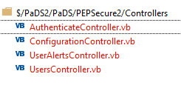
CORS enabling is handled in PEPSecure2/App_Start/WebApiConfig.vb file. Valid Origins are read from database stblParameters parameter CORSAllowedOrigins. To add new origins you need to put the origin value in the stblParameters CORSAllowedOrigins ParameterValue field with a comma separation between values.

Federated Application Setup
The Federated application provides a portal to the OpenAthens system to allow users to authenticate on OpenAthens with a single signon and then be logged on to PEPweb with the permissions of their universities or institutions subscription.
It is setup as an application in IIS with the code stored in the following location C:\wwwroot\ Federated.
Federated needs to be setup in IIS as an application under the PaDS_Live website as per screenshot below and needs to be on PaDS01 and PaDS02 servers.
Federated has to run under its own Application pool in IIS called Federated and is run under \zedraadmin account.
When setting application pool make sure it has the following basic settings.
Select advanced settings link and make sure the settings are as follows.
In IIS8 select Federated application and click basic settings and advanced settings and set as below screenshots.
Make sure Federated folder in C:\wwwroot\ Federated has the following permissions.

Application Security

General
There are two security methods in use in the PaDS applications:
If rebuilding the server from scratch, you need to add the following users to the server:
- ZedraAdmin
- PadsReporter
- IJP_FTP
- PEP_FTP (Note: to add this user, you must disable password policy as detailed below)
Open Local Security Policy by clicking the Start button, typing secpol.msc into the Search box, and then clicking secpol. ‌ If you are prompted for an administrator password or confirmation, type the password or provide confirmation.
In the Navigation pane, double-click Account Policies, and then click Password Policy.
Double-click the item in the Policy list that you wish to change.
- SQLServerUser
All passwords are in LastPass.

Web Site Application Security
A list of valid users are stored within the PaDS table RemoteUser. All users must log on to PaDS to access any of the pages and their log-ons are validated against this table. SuperCompanyAdmins users can maintain users through the website.

Security Groups
The following security levels will be supported.
No | Security Group | Web Authority Level | Access Rights
0 | Anonymous User | ~ | Can access the remote order entry page and place an order
1 | Remote Individual User | User | Can log on to the system over the web, update their subscriber and account details and order products
2 | Remote Organisation User | GroupUser | Same as above but for an organisation.
3 | Remote Organisation Admin User | GroupAdmins | Maintain subscriber records for people within selected organisations.
4 | Remote Company Admin Operator | CompanyAdmins | Access to all above and company-based functions:  - Process payments (Cashbook)  - Despatch Orders  - Administration Tool
5 | Super Administrator | SuperCompanyAdmin | Access to all application functions, including :  - Add and delete users  - Reset passwords  - Assign user access rights  - Process new subscriber records
6 | System Administrator | -- | Administrator rights to the Server and all aspects of the website and database
7 | Remote Organisation Subscription Renewer | GroupRenewer | Can logon and create new group subscriber renewals. Can only see pg462SubscriberRenewals.aspx
Access to some of the functions available to 6 & 6 is only possible if the user has been set up as an NT user on the server and given access to group PaDSSuperCompanyAdmins

Access Rights
A user’s ability to see and change records within the system is based on two things:
- Web Authority Level – as describer is 3.2. This controls which functions the user has access to.
- Access Rights – this controls which data the user can see and update.
Access Rights are set up in the web user maintenance page. A user is given access to companies and subscribers. What this means depends on the Authority Level:
No | Authority Level | Access Rights: | Access Rights
1 | User | Subscriber | Allows the user to amend that one subscriber record
 |  | Company | Allows user to order products from that company
2 | GroupUser | Subscriber | Allows the user to amend that one subscriber record
 |  | Company | Allows user to order products from that company
3 | GroupAdmins | Subscriber | Allows the user to maintain any subscribers that are affiliated to allowed subscriber.  Allows user to add new affiliates
 |  | Company | Allows user to order products from that company on behalf of any of the affiliates
4 | CompanyAdmins | Subscriber | Allows the user to maintain any subscribers that are affiliated to allowed subscriber.  Allows user to add new affiliates
 |  | Company | For the company the user can:  - Add Orders  - Confirm Orders  - Process Payments  - Process Bank Deposits  - Despatch Orders  - Order that Company’s Products
5 | SuperCompanyAdmin | Subscriber | There is one user 30000 to which all new subscribers are affiliated. Access to this subscriber gives a SuperCompanyAdmin user access rights to all subscriber records
 |  | Company | For the company the user can:  - Add Orders  - Confirm Orders  - Process Payments  - Process Bank Deposits  - Despatch Orders  - Order that Company’s Products
6 | GroupRenewer | Company | Allows User to create group subscription renewals for the subscriber they have rights to.

Technical Implementation
These complex security rights are implemented slightly differently on the website:

Web Site
There are two SQL server functions which are used to limit the records that can be seen by the user:
f520SecureSubscriber – This is passed the user-id and a date and it will return all the subscribers the user has access to on that date.
f530SecureCompany – This is passed the user-id and returns all the companies the user has access to.

SERVER CHECKS and Alerts

PaDs Checks
Page pg080PaDSChecks.aspx checks various parts of the system and if any are missing it throws an error.
https://www.psychoanalystdatabase.com/pages/pg080PadsCheck.aspx?LogCommand=Login&UserName=ZedraCheck&Password=DGHmnd96B45Y
This URL is monitored by Pingdom and if any failure is detected, Zedra is informed by email and text.

“Read Only” and “Failover” Modes

“Read Only” Mode
The load balancer sends traffic to mirrored applications on either the primary or the secondary server. The first thing any part of the application does is to try and connect to the database on the primary server. If this is found, then the system works normally. If the primary database is not found, then the system will automatically run in “Read Only” mode using the databases on the secondary server. In “Read Only” mode, the PEPweb authentication will work normally and PaDS web users will be able to view data but not make any changes, or add orders.
As soon as PaDS enters “Read Only” mode, Zedra is informed and will attempt to fix the issue with the primary server. PaDS has been using the Amazon servers since 2010 and in that time the primary server has only ever been down for a few minutes.
When the primary server becomes available again, PaDS will automatically resume working normally.
If a connection cannot be made to the secondary database only, then this will be reported to Zedra, but PaDS will work normally.
The databases on the secondary server are restored from copies of the databases on the primary server every ½ hour (see section 4.4).

“Failover” Mode
If the system is in “Read Only” mode for more than a configurable amount of time, currently 24 hours, the system will automatically switch to “Failover” mode. In “Failover” mode, the system will automatically make adjustments to the databases on the secondary server so that all aspects of the system can be used against the secondary databases. “Failover” mode has been tried in testing, but since 2010 has never been necessary in the live environment.
If PaDS is in “Failover” mode due to a complete loss of the databases on the primary server, then there could be up to a ½ hours worth of data updates which are not integrated into the databases of the secondary server. The critical parts of this missing information, (orders, cashbook items and deposits) can be found in the SecondaryAuditLog table in the PaDSSecondaryAuditLog database on the secondary server. This can be used to reconstruct any vital missing data.

Recover from “Failover” Mode

Check Elastic IP has been Reset

Check Internal IP has not Changed
It should only change if one of the servers has been stopped and restarted. If it has changed, the new Internal IP Address must be added to the hosts files (see section 3.2.b).

Assess how many Updates made on Secondary DB.
  - Check with IJP and PEP to see if they have made any/many updates
  - Check to see if there are any new Orders.
  - If there are negligible updates, then skip to Error! Reference source not found.

Mark Pads as Read Only
  - There is a script ObjectRightsReadOnly.sql in source safe

Backup Logs and Pads_Live Databases on Secondary

Backup Logs and PaDSLive on Primary

If New, or stopped and started, PaDS01
- Set New private IP in:
  - Hosts file on both servers
  - Load Balancer Target Groups
  - DB Parameter LiveIPAddresses

Restore Secondary DBs onto Primary, then
- DB File names (Properties in SQL Manager) may have datetime in name which should be removed. They should be PaDS_Live , PaDS_Live_Log
- Run CreateUsersAndRoles.sql
- Re-compile primary SQL - Open C:\Pads\PaDSTestHarnessUtilities\PaDSTestHarness.exe Click “Compile 1st SQL”, check log file (June 2019: This can’t be done until after setting FailOverThisIsMasterServer as it will try and run against PaDS02)

Check Parameters on Primary
- Set FailOverThisIsMasterServer value in stlbParameters to 0 in Primary and Secondary DB

Copy DB to Secondary
Check this has run.

Backup
The databases are backed up every ½ hour and copied to the secondary server (see section 4.4).
All other key files and the database backup files are backed up to iDrive every night at 4:10am (July 2021: Changed to 4:10 so it does not conflict with the ½ hourly database backup). This runs under the Administrator user and you need to be logged onto Administrator to see it.

PaDS Maintenance and Procedures

PaDS Release to Test
Version:
Action | Done
Pads Test is a copy of PaDS01 server on Amazon AWS.
Stop Pads Batch Control
Copy changed SQL files to C:\Pads\SQLLive folder.
If required run DBUpgrade.sql on Pads_Live.
Open C:\Pads\PaDSTestHarness\PaDSTestHarness.exe
Click “Compile 1st SQL”, check log file
Copy the release files from the version directory into the relevant directories.
In particular BussinessLogic.dll should go into:
- C:\Pads\PaDSBatchControl
- C:\Pads\ PaDSTestHarness
- C:\wwwroot\PEPProductLive\bin
- C:\wwwroot\PaDS_Live
- C:\wwwroot\PEPSecure\bin (Update dll’s only)
- C:\wwwroot\Federated\bin (Update dll’s only)
If Pads ReportTemplates have changed they need to be placed in C:\Dropbox\PaDSTest\ReportTemplates folder.
Start Pads01 BatchControl
Ensure server is running the correct version and check all changes are working at following URL:
- https://stage-pads.pep-web.rocks/pages/pg070Logon.aspx
Update these notes with anything new.

PaDS Release to Live
Version:
Action | Done
On Pads01 server create copies of the directories that will be changed in C:\Pads\Versions\xxxx\ called “BeforeLiveUpdate”
Force CopyPaDSDatabaseToSecondary to run and complete.

Stop Pads01 Batch Control
Copy changed SQL files to C:\Pads\SQLLive folder from PaDS test.
If required run DBUpgrade.sql on Primary only.
Open C:\Pads\PaDSTestHarness\PaDSTestHarness.exe
Click “Compile 1st SQL”, check log file
Copy the release files from the version directory into the relevant directories.
In particular BussinessLogic.dll should go into:
- C:\Pads\PaDSBatchControl
- C:\Pads\ PaDSTestHarness
- C:\wwwroot\PEPProductLive\bin
- C:\wwwroot\PaDS_Live
- C:\wwwroot\PEPSecure\bin
- C:\wwwroot\Federated\bin
- \\pads02\C$\wwwroot\PaDS_Live
- \\pads02\C$\wwwroot\PEPProductLive
- \\pads02\C$\wwwroot\PEPSecure (Update dll’s only)
- \\pads02\C$\wwwroot\Federated (Update dll’s only)
If Pads ReportTemplates have changed they need to be placed in C:\Dropbox\PaDSLive\ReportTemplates folder.
Start Pads01 BatchControl and check that CopyPaDSDatabaseToSecondaryServer job has ran this copies all Database changes to Pads02 database.
Ensure both servers are running the correct version:
- http://Primary.psychoanalystdatabase.com
- http://secondary.psychoanalystdatabase.com
Copy full solution source to Dropbox, \Dropbox\PaDSLive\PaDSSourceCode\
Merge PaDS changes into PaDSForGitHub in Visual Studio as per 9.3 section in admin manual.
Zip PaDSForGitHub and upload to GitHub as detailed in section 10 of admin manual.
Rename PaDSForGitHub to PaDSForGitHub_vxx.xx_dd-mm-yyyy and then upload to \Dropbox\PaDSLive\PaDSSourceCode\ directory.
Update these notes with anything new.

Merging PaDS changes to Github version in Visual Studio
Once a release is complete you need to update PaDSForGitHub in Visual Studio Source Control Explorer.
Aug 2021: This must be done in co-ordination with applying the latest DBUpgrade to the backup “try” databases stored in D:\Projects\PaDS2\PaDSForGitHub\BusinessLogic\SQL\DBCreation
The SQL DB Creation file must also be updated. This
First right click PaDS then Branching and Merging and then Merge as per screen shot below.
You will be shown the following window with Source and Target branch already defaulted.
Select Next and Next and then Finish and the merge will complete.
Check that changes exist in PaDSForGitHub and then Zip up file and copy to PaDs GitHub repository.

Take Snapshot and Install Windows Updates
Each month Microsoft release updates to windows and other software. These updates will be applied to both servers once a snapshot of the server has been taken. Doing it this way will ensure the software updates are applied in a timely manner, but also ensure that we also have a reasonably up-to-date image of both servers.
So, for each server.
Action | Done
PaDS02: Instigate a Create Image of the server:
- Name PaDS01/2 W2016 yyyy-mm-dd
Ensure the “No Reboot” flag is set.
PaDS02: Wait until image created
PaDS02: Apply Windows, and other software, updates.
(May require a reboot.)
PaDS01: Stop PaDS Batch Control and set to “Manual” start up.
(This is to ensure that an outstanding jobs don’t get run by mistake when a clone of the server is taken)
PaDS01: Instigate a Create Image of the server in AWS console: http://console.aws.amazon.com/ec2/home?&region=us-east-1
- Name PaDS01/2 W2016 yyyy-mm-dd
- Ensure the “No Reboot” flag is set.
PaDS01: Wait until image created (can take a while)
PaDS01: Apply Windows, and other software, updates.
(May require a reboot.)
Check that primary SQL server is running in Services before starting batch control.
PaDS01: Start PaDS Batch Control and set to Automatic start up.
PaDS01: Check main PaDS features are working OK.
- Front end - Admin
- Front end – Remote User
- PEP Product
- Copy DB to secondary
Delete previous month’s AMIs (Images), ensure that the volumes for those images have also been deleted.
- In the navigation bar, verify your region.
- In the navigation panel, click AMIs.
- Select the AMI, click Actions, and then click Deregister. When prompted for confirmation, click Continue.
- In the navigation pane, click Snapshots.
- Select the snapshot, click Actions, and then click Delete.

Once complete you need to check that the C drive on both servers has at least 10GB of free space available.
If not, then we need to do the procedure as detailed in 9.5 AWS Volumes Disk Sizing below in this document.

Microsoft Monthly Updates
If MS Updates take a long time to install then you may have to do the process manually as detailed below.

1. Open Services console on this server (Services.msc) 2. Look for Windows Update Service and BITS (Background Intelligent Transfer Service) and Stop the service.
OR
You can also use command prompt to stop the service. Open command prompt (run as admin) and type command net stop wuauserv and net stop bits to stop these services.

3. Go to the following location.
C:\Windows\SoftwareDistribution\Download and Delete everything in the folder, but do not delete the folder itself. To do so, press CTRL + A to select everything and then press Delete to remove the files.

Note: If the files can’t be deleted because they’re in use, you’ll need to restart your PC. Turn off the two Windows Update services and then try to delete the files again.

4. Again open windows services and restart the services ( windows update, BITS ) which you previously stopped. or Use command net start wuauserv and net start bits to Bring up these services.

Next download the relevant update from the following MS update catalogue site.
https://www.catalog.update.microsoft.com/Search.aspx
Then enter update number in search box. After downloading update then install and follow on screen prompts.

AWS Volumes Disk Sizing
These can be easily expanded:
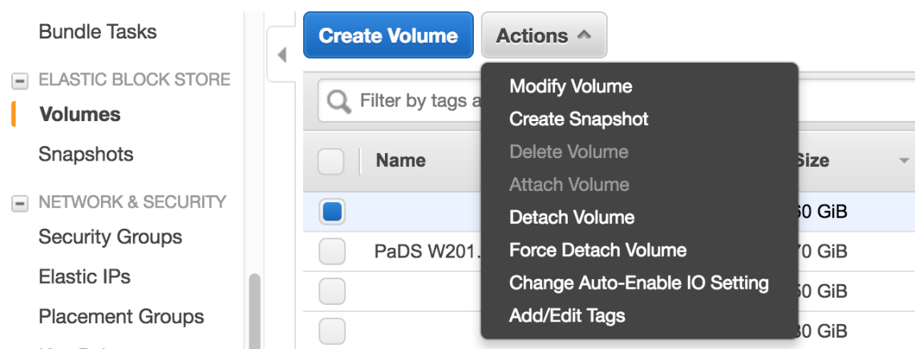
Once this has been done and has taken effect, the server will need to be rebooted and the drive will need to be expanded in Windows server manager:
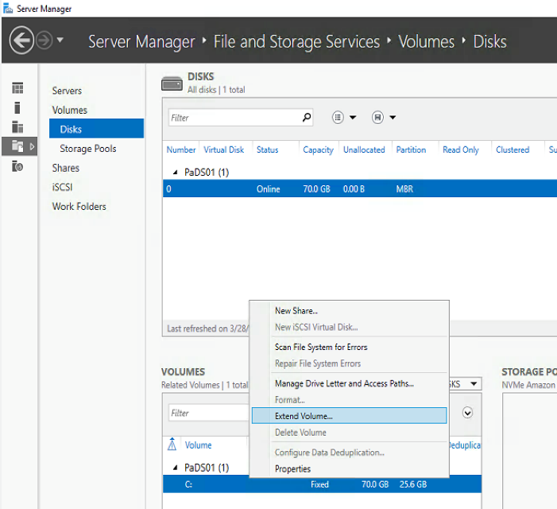

Clover Security PCI compliance
PCI compliance for credit card authorisation is carried out by First Data. This is a self assessment process.
NOTE:After several phone calls to First Data they confirmed that we do not have to do the PCI scan version as the credit card authorisation is handled by Cybersource. This process has to be reviewed annually.
Logon details and date of next review for First Data PCI compliance is in LastPass.

Clover Security PCI compliance vulnerabilities fix 2020
Setting the hostname in Internet Information Services (IIS) 7.0 and above.
To use the appcmd command, we need to enable IIS Management Scripts and Tools option in IIS.
Here is step by step how to enable it:
1. Open Turn Windows features on or off.
2. Enable IIS Management Scripts and Tools under “Internet Information Services” => “Web Management Tools”.
3. We will see the appcmd.exe in C:\Windows\System32\inetsrv folder then.
4. Add C:\Windows\System32\inetsrv to PATH system environment variable.
Next use command line to run following command
C:\Windows\System32\inetsrv>appcmd.exe set config -section:system.webServer/serverRuntime /alternateHostName:"padstest.zedra.net" /commit:apphost
If it runs ok you will see the following message
Applied configuration changes to section "system.webServer/serverRuntime" for "MACHINE/WEBROOT/APPHOST" at configuration commit path "MACHINE/WEBROOT/APPHOST"
Add the following Response Headers to web.config
<system.webServer>
<httpProtocol>
<customHeaders>
<add name="X-Frame-Options" value="SAMEORIGIN" />
<add name="X-XSS-Protection" value="1; mode=block" />
<add name="X-Content-Type-Options" value="nosniff" />
<add name="Strict-Transport-Security" value="max-age=31536000; includeSubDomains; preload" />
</customHeaders>
</httpProtocol>
</system.webServer>

Amazon Test Server Setup
To Create a test server
- Select AIM of Pads01 and launch
  - Select M5-Large server
  - Select security group PaDS2018 Test
- Once instance has started:
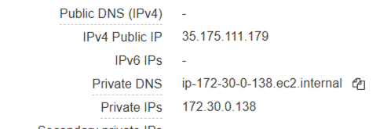
  - Point elastic IP Address 54.211.127.208 at the new server
  - In Zonomi padstest.zedra.net points to fixed (elastic) IP Address 54.211.127.208, this does not need to be changed.
  - Log on and change hosts file so that all 4 lines point to the private IP
  - Path: C:\Windows\System32\Drivers\etc\hosts
- In TFS file:
  - Open D:\Projects\PaDS2\PaDS\BusinessLogic\SQL\Scripts\Amazon Test Server Post Restore Updates.sql
  - Change @PaDS01PrivateIPAddress , and update insert lines for all parameters as detailed in the comments in Amazon Test Server Post Restore Updates.sql file.. The parameter insert lines should NOT be saved in this file.
  - Run on “Live” DB on test server
- Update cybersource endpoint in web.config to point at test version
- Update cybersource endpoint in BatchControl PaDSBatchControl.exe.config file found in C:\Pads\PaDSBatchControl to https://ics2wstest.ic3.com/commerce/1.x/transactionProcessor and stop and restart batch control after change.
- Update cybersource endpoint in PaDSTestHarness.exe.config file found in C:\Pads\PaDSTestHarness to https://ics2wstest.ic3.com/commerce/1.x/transactionProcessor also change PEPProduct endpoint address in same file to http://stage-pads.pep-web.rocks/PEPProductLive/PEPProduct.asmx"
- Batch Control
  - All Pending are paused in “Update Amazon Test Server Parameters.sql”
  - Renewal emails can be unpaused but send all to @zedra.co.uk
  - Backup job will fail and should stay paused
- Setup a reminder to review server in a week or so and either STOP or DELETE the instance.
- SSL certificate for stage-pads.pep-web.rocks & stage-pads.pep-web.org is an Amazon certificate which is attached to the PaDS Test load balancer so no procedure needed for certificate. Old certificate padstest.zedra.net is no longer used.
- After the server has been setup we need to run PadsTestHarness and select the Delete/Add Test Data button in Orange section to populate the Test data into the Pads test database.
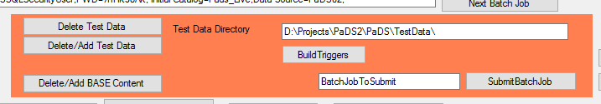

Enable PepWeb Universal Content
Some PepWeb Content is made universally available to everyone in PEPWeb to do this follow this procedure.
- Populate the Pads database parameter UniversalContentRegPtrn in stblParameters table with the required document Id in regular expression format.
Example: 0000A|PEPGRANTVS.001.0002A|pepgrantsvs.001.0002a
- Make sure each document id is separated with a | and add the id in Upper and lower case.
- For test use the following https://stage.pep-web.rocks/browse/document/Doc Id here to check.
- For live use the following https://pep-web.rocks/browse/document/Doc Id here to check

Open Source and GitHub
The latest version of the PaDS software and admin manual will be available on GitHub:
https://github.com/Psychoanalytic-Electronic-Publishing/PaDS/
After each release to Live/Production the changes in the PaDS2/Pads project in Team Foundation Server will be merged into the PaDS2/PaDSForGitHub version on TFS.
All passwords in this version of the source code have been replaced with xxObscuredPasswordxx, which can be easily searches for and replaced if required for a new development environment.
To upload PaDSForGitHub to Github first logon to Psychoanalytic-Electronic-Publishing (github.com).
Next select PaDS link from the front page as below screenshot
From the next screen select the Add file and then Upload files.
The following screen drag the Zipped PaDSForGitHub folder to the following box.
And then Commit changes button.
This completes the file upload to Github process.

PEPweb Authorisations and Content Sets
Whenever the PEP content server (OPAS) is asked for a full read of some content it asks PaDS whether the currently logged on user has rights to that particular document ID.

Content Catalogue Synchronisation
PaDS has a process which automatically retrieves all the current document IDs from OPAS, this process currently runs once a week.

Content Sets
Pads has a concept of “Content Sets” which allow portions of the OPAS catalogue to be flexibly defined based on the below criteria. The PaDS pages to maintain content sets have details descriptions of how the criteria fit together.
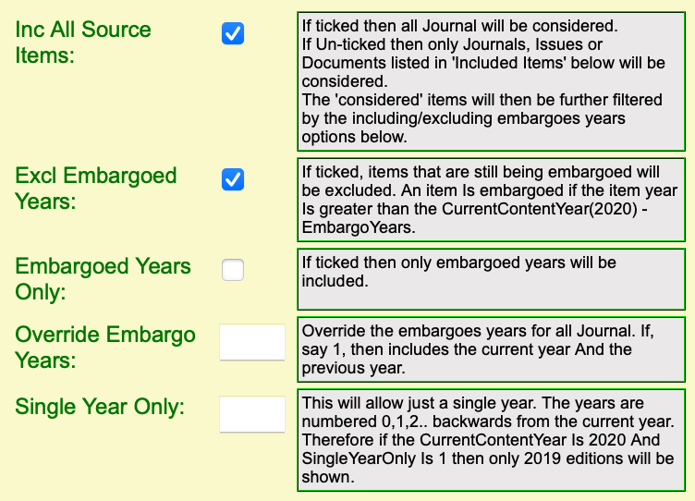
- Source types (Journal, Book, Video)
  - A content set can be defined as including all or some of the above types
- Embargoed Years
  - Against each journal the embargoes years are defined. This is used in conjuction with the PaDS parameter (CurrentContentYear) in table stblParameters and the documents publication year to define if a document within that journal is embargoes or not.
- Embargoes years only
  - This is used to reverse the above so that embargoes documents are available but non-embargoes are not.
- Override Embargoed Years
  - This overrides the embargoed years defined against the journal with an entered value
- Single Year Only
  - This will allow just a single year. The years are numbered 0,1,2.. backwards from the current year. Therefore if the CurrentContentYear Is 2020 And SingleYearOnly Is 1 then only 2019 editions will be shown.
- Individually Specifies Items
  - It is also possible to define a content set as individual items of content be it, journals, volumes, documents, books or videos.
  - 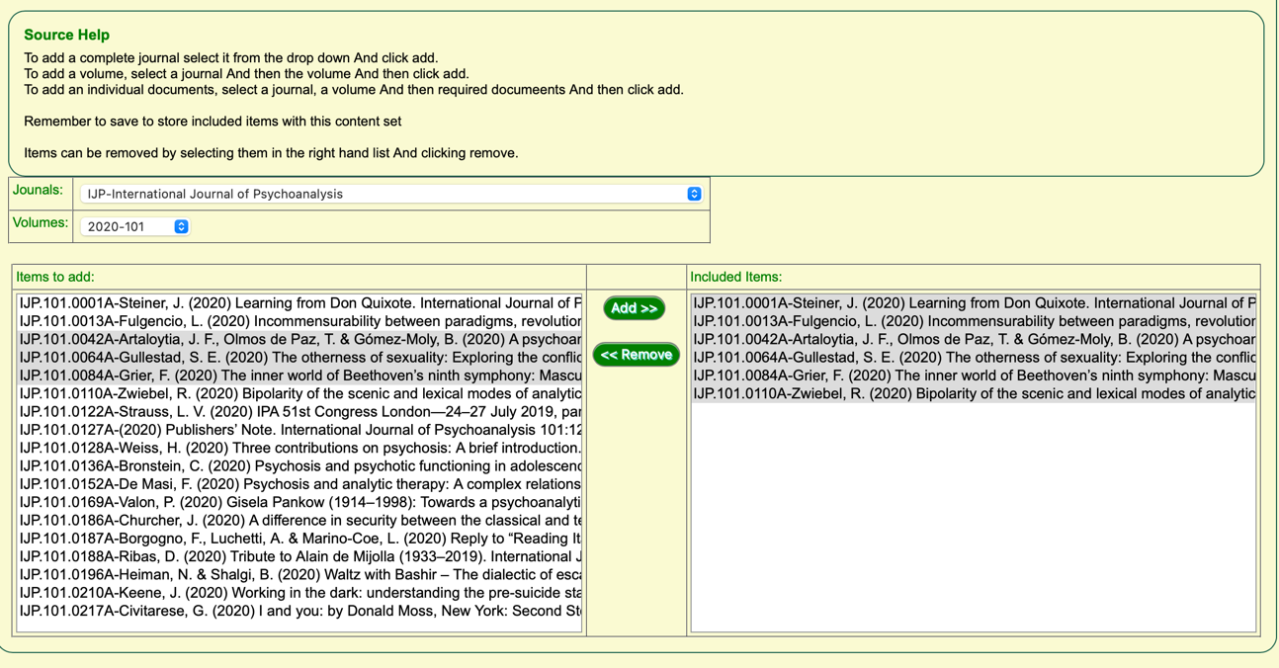

Sales Orders, Products & Subscriptions
PaDS Sales orders specify which products have been subscribed to and for how long. Against a product it is possible to specify which content sets the purchase of that product will give access to.
Individual PaDS users are associated with a sales order, and therefore a subscription, in the following ways:
- Direct
  - The user is directly linked to the subscriber which purchased the product
- Block
  - An institution or group has purchased a product and specified a set of subscribers, linked to individual users, who can benefit from the subscription.
- Auto Logons
  - An individual user has used one of the three auto logon methods to gain access to the PEP web system.
    - If they do not log on they will be given generic “group user” access via the sales order purchased by the institution linked to the group user.
    - If they do log on the user ID will then be associated with the “group user” that purchased the subscription, for a period of 90 days.
  - The three auto logon methods are as follows:
    - IP Address – the user has open PEP from an IP address known to PaDS
    - Referrer URL – the user has opened PEP from a Referrer URL known to PaDS
    - Federated/OpenAthens – the user has opened PEP and then logged on using a Federated/OpenAthens user which is associated with an institution which is known to PaDS.

Admin Access
PaDS users which have authority level of company admin ,or super company admin, and have rights to the PEP company, will automatically be given access to all PEP Web content. This is achieved via one or more Content Sets which are specified in the PaDS parameter AllContentSetIdsForAdmin. This is currently content set 1- All Content for Admin Users.

Universal Access
Some documents need to be available to all users of the system whether they are logged on or not. This is achieved using PaDS parameter UniversalContentRegPtrn which is a Regular Expression applied against the document ID. If it matches the document is universally available. The expression is currently 0000A which matches all book index documents. This can be updated and tested on the PaDS Content Set list page:
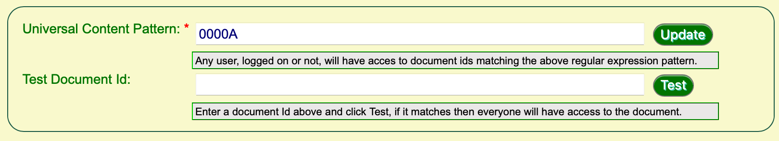

Appendix A – document Control

Document History
Issue | Date | Author | Reasons
0.1a | 07/02/02 | James Woosnam | First Draft for internal review
0.1b | 01/04/05 | Julian Gates | Updated for Windows 2003
0.1c | 21/02/12 | Julian Gates | Updated for new Pads 64-bit Server
0.4a | 22/05/17 | Julian Gates | Brought up to date
5.0a | 04/04/18 | Julian Gates & James Woosnam | Windows 2016 Servers
5.0c | 04/03/19 | Julian Gates & James Woosnam | Reviewed
5.0d | 04/03/20 | Julian Gates & James Woosnam | Reviewed and Updated
6.0a | 19/05/21 | Julian Gates & James Woosnam | Reviewed and Updated with details of integration with PEPweb 2021.
6.0b | 18/8/21 | James Woosnam | Minor updates and a Section on PEP web authorisations and content sets added

